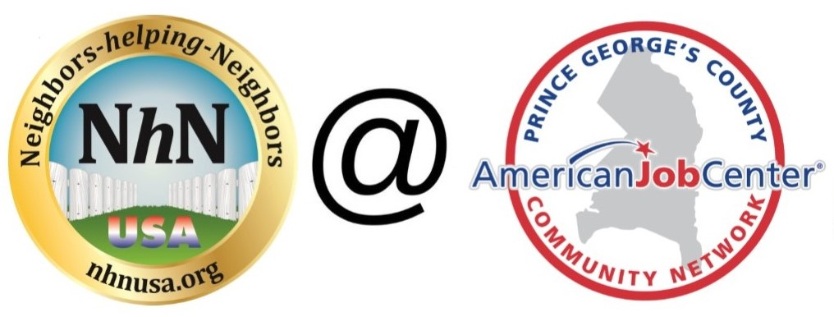

Weekly Meeting Agenda
(Agenda to be followed each and every week)

- Upon arrival at meeting all new members please fill in contact information form with email
- Any announcements from partners always Open with Group Mission- Pay it forward culture
- Facilitator announce up front that we keep the meeting on a very positive note
- And each week we ask a different member to lead the meeting.

Facilitator – brief statement of group mission

- Brief Introduction (basically 30 second version of elevator pitch) by each attendee to include:
  - Name
  - Background/Previous Employer
  - Expertise & Role you are looking for
  - Companies you are targeting
  - Name ( slow and clear )

- Return to New Members for some additional time

- All members, must update the group on week’s progress for job search and leads

- Job Leads/Opportunities (from all)
  - Request for contacts
  - Hot companies
  - Upcoming Networking Events
  - Lessons Learned this week
  - Volunteering opportunities

- Group open discussion & specific calls for help (from all)
- 15 minutes from representatives of employers, other resource organizations.

- Encourage all members to post job leads into LinkedIn local and national NhN groups
- Encourage all to visit web site at : www.nhnusa.org www.jobsearch2018.com
- Prince George’s LWDB AJC sites [ list links ]
- Help each other each week with different areas of job search: networking, using LinkedIn, interviewing, peer resume reviews, work as buddies in between meetings.

- Other Business (from all)

