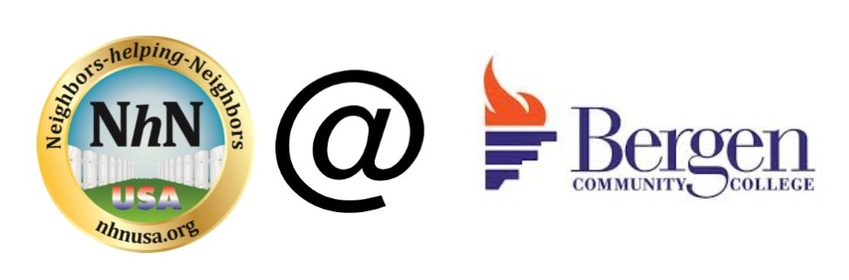
Weekly NhN Meeting Agenda
(Agenda to be followed each and every week)

- Upon arrival at meeting all new members please fill in contact information form with email
- Any announcements from college partner
- Leader opens with group mission, Pay it forward culture and announce up front that we keep the meeting on a very positive note

Facilitator – brief statement of group mission

- Brief Introduction (basically 30 second version of elevator pitch) by each attendee to include:
  - Name
  - Background/Previous Employer
  - Expertise & Role you are looking for
  - Companies you are targeting
  - Name ( slow and clear )

- Return to New Members for some additional time

- All members, must update the group on week’s progress for job search and leads

- Job Leads/Opportunities (from all)
  - Request for contacts
  - Hot companies
  - Upcoming Networking Events
  - Lessons Learned this week
  - Volunteering opportunities

- Group open discussion & specific calls for help (from all)

- Encourage all members to post job leads into LinkedIn NhN group
- Encourage all to visit web site at : www.nhnusa.org www.jobsearch2018.com www.jobs411.org
- Ready To Work NJ - LTU unemployed or underemployed register www.rtwnj.org
- NJ department of labor site http://careerconnections.nj.gov/
- Help each other each week with different areas of job search: interviewing, peer resume reviews, work with buddies in between meetings.
- Depending on time - Other Business (from all)
- 15 – 20 minutes presentation, invited guests, that we schedule to attend that week

