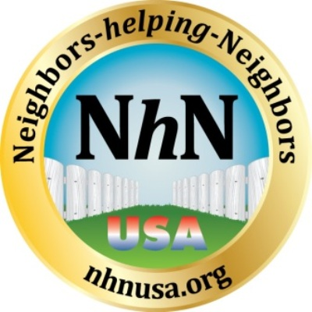

Meeting and Member Policies for Neighbors-helping-Neighbors USA, Inc. – Weekly meetings

Applies to all nhn meetings in all venues – Libraries, Colleges and Microsoft Retail Stores.

NhN group functions as a support group for all our members who assist each other in techniques and suggestions to improve their job search efforts, offer support, and help with personal and professional networking to find a position.

Our meetings are private and personal and provide extreme value to our out of work members. They are not a source for Career Professionals and other types of product and service business people to find clients! Anyone with the intent of prospecting or selling their services at our meetings is strictly prohibited and non-members are not welcome to attend our weekly meetings. In addition, conducting business is prohibited at all of the venues where we hold our meetings. This includes any type of financial services, multi-level-marketing of any kind, energy sales or any product or service that is commission-based sales.

We are a support group and want to be able to continue the wonderful nurturing meeting environment that we have delivered from the first meetings held. The limited time the members have (90 minutes) to conduct our weekly meetings is too valuable to have any non-agenda conversation or time taken away from the meeting format. This includes any form of discussion or solicitation even by other networking group members. Our local facilitators are not authorized to allow anyone who is not a qualifying member (categories spelled out on flyer) to attend our meetings.

We are greatly appreciative when career coaches and other helpful professionals express interest in providing their expertise on a pro bono basis. However, to adhere to the mission of the group, membership and attendance is only open to job seekers and former members who have obtained employment. Approval by the founder is required for all presentations to our weekly meeting groups.

Job search advisors are more than welcome to contact the founder to schedule attendance at a meeting, but are required to provide a specific agenda for the founder/president to approve in advance. The local facilitators are authorized to politely decline inappropriate material which is not aligned with our mission statement, and any members contacted by a non-approved person should notify the founder immediately.

For members only:
We do ask when you land a position you report it to your local leaders and to the founder as it is important that we track our progress. Member landings give hope to all the other members which is important.

All NhN materials and other member’s email addresses are confidential and used for the sole purpose of assisting our members with their job search. Information may not be distributed to anyone outside of the group – especially phone numbers and email addresses – without express permission from the NhN founder/president and group leader.

Any further questions must be directly addressed to John R. Fugazzie the Founder/President and Group Leader. Visit our Web site www.nhnusa.org
Neighbors-helping-Neighbors USA established Jan 27, 2011, the name, logo and materials are property of John Fugazzie founder and no duplication or use of these materials can be done with out express permission.

