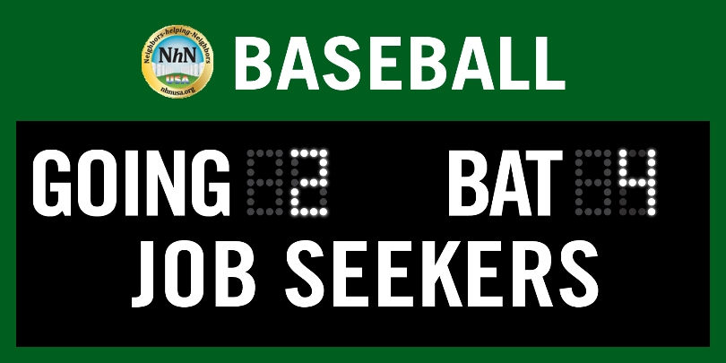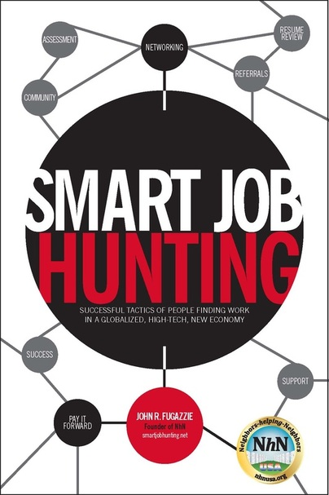

Going2bat4JobSeekers - Coaching Staff's Training & Educational Game Program
 Pre-Game Batting Practice and Preparation
Learning the Finer Points of the Job Search Game
(The better you know the game the better you can perform)
Chase Your Passion
(Making the Team of Your Choice)
Having a Sports/Athlete Winning Positive Attitude
(Own your Game with a Can do – Will do – Just do it)
Continuous Motivation to Out search the Competition
(Must Play Intense the Full Game)
Driven to Win
(There is No Crying in baseball - Winning is Everything )

Opening Innings of the Game ( Innings 1-3 )
Build Your Game Plan to Attack the Job Search
(How are you going to pitch to each target job/industry?)
Personal Branding
(Build your fan base with everyone)
Resumes
(Your Baseball Card)

Middle of the Game ( Innings 4-7 )
Networking - Networking - Networking
(Most Important Game Skill you can Develop)
30 second commercial - Elevator Pitch
(Your WoW Factor what brings your Fans out to Watch)
Using LinkedIn.com
( Let Your Fans and Former Teammates Help)
Personal Networking
( You are the Star of your Game)
Social Media (Facebook, Twitter, and LinkedIn
(The Positions Each Plays the Best)
Crunch Time the last six outs ( Innings 8 and 9 )

Interview Skills and Strategies
(Get a Quality at Bat Every Time Up)
Proper Follow Up
(Game is not over till the last out is squeezed)
Why are you the #1 out of the other 8-10 picks
(They Should Pick for Their Team)

Being a Winners and separating yourself from all the Others
(Your Game performance that will make you MVP)
Closing the Deal
(Game is not over until either Mariano closes the final out)
The Job Seeker Wins....thaaaaaa Job Seeker wins!

Contact john@going2bat4jobseekers.org 201-262-0103 www.abbyacrossamerica.com www.nhnusa.org

