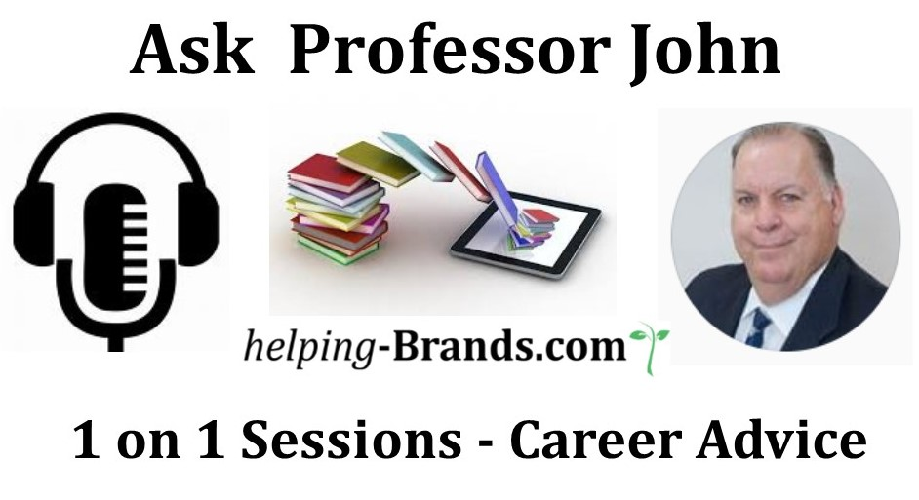
Book 1 on 1 session

It is important you have done the self-assessment before others can help you and that you have an idea of where you want to go next in your career.

JOB SEARCH ASSESSMENT LIST

- 1. Have you done self-exploration to see if your current career is your next career?
- 2. Are you happy in your current career?
- 3. Do you want to investigate a career change?
- 4. Do you need to see a career counselor?
- 5. Have you outlined a clear career path/track for yourself?
- 6. Have you done a self-assessment of your experience, skills, abilities, values, talents, strengths/weaknesses, likes/dislikes, “must haves”/”don’t wants”?
- 7. Do you need to do an interest assessment (i.e. Myers/Briggs or Strong/Campbell)?
- 8. Do you have a person or group of people who you can bounce ideas off of or get honest feedback from?
- 9. Do you need to learn something to increase your chances of getting a job?
- 10. Do you have a plan to organize and schedule your job search?
  - Daily, weekly, monthly activity log?
  - Do you have a record keeping system for your job search?
- 11. Do you have a template for gathering data for employment applications? Don’t forget your volunteer work. Key accomplishments and experience. Employment contact information and dates.
- 12. Do you have a clear understanding of the job that you want and how you qualify for it?
- 13. Have you identified your core transferable skills?
- 14. Do you know the keywords in your industry and for your job?
- 15. Have you identified and developed your unique selling proposition and how you can distinguish yourself from others?
- 16. Do you have an understanding of branding yourself and the importance of marketing skills in the job hunt.
- 17. Do you know how to do a job search? Online websites? Using your contacts? Through networking?
- 18. How many companies have you targeted? 5-10 10-20 40-50 100?
  - What makes them your target list? Evaluations and ranking them.
  - Do you know how to research them? Where to get good reviews and information?
  - Campaign plan/strategy and preparation for each one? Have your ranked your list?
- 19. Resume done?
- More than one if needed?
- Researched dos & don’ts of a great resume?
- Have a scan able one for applications and online use? Do you know about ATS?
- Are you using keywords?
- 20. Your references? Have you given them your resume? Do you contact them before your interview and let them know to be ready? Do you have more than enough of them?
  - Are you keeping them engaged in your job search and do you remember to thank them.
- 21. Basic cover letter? Do you know how to write one? Elements of a good cover letter?
- 22. Thank you cards? Investigate what you need to write? Did you buy some nice ones yet? Thank You’s are not just for interviews but for anyone who has gone out of their way to help you. Practice using them.
- 23. Elevator speech?
- 24. Business cards?

Networking, your contacts and a PLAN to contact them:
- 25. Do you have a complete list of immediate (family & friends), professional, peripheral/acquaintances/past and “want to” or “need to” contacts?
- 26. Going to job clubs and networking groups?
- 27. Business associations, Chambers of commerce, Rotary, religious organizations, Alumni, Meetups, etc.?

Job search planning and development:
- 28. Using your One Stop career centers?
- 29. Sourcing venues to get constructive training: seminars and workshops?
- 30. Do you have a career mentor or do you need to find one?
- 31. Do you belong or use Trade journals and industry specific websites? They can be a good place to find advertised leads and contacts or to keep up on your industry.
- 32. Have you cleaned up your online presence?
- 33. Do you know how to keep up your skill sets and training?
- 34. Have you searched for good recruiters and employment/placement agencies?
- 35. Are you willing to do consulting and or temporary assignments? Have you researched your expertise and labor market information so that you know if you can use these alternatives?

Are you on LinkedIn? Other social media sites?
- 36. Profile complete? Almost complete? Not started yet?
- 37. Have your picture?
- 38. Belong to groups/associations?
- 39. Post something every day? Once a week?
- 40. Get recommendations and give them?
- 41. Have endorsements? Make them for others?
- 42. Written a generic request note and a thank you note for soliciting connections?

Interviewing:
- 43. Mock interviews and practice interviewing questions
- 44. Do you know how to do: phone, Skype, panel and mealtime interviews
- 45. How to answer tough interview questions STAR/PAR/SAR
- 46. Prepared for an interview—have your outfit ready? –Try a dry run to get there on time?
- 47. Are you prepared to answer unlawful/inappropriate questions?
- 48. What to bring to an interview
- 49. What to do after the interview. Did you ask about next steps?
- 50. Informational interviews—why and how to use them. Learn something and don’t ask for a job ask for a referral or contact.
- 51. Building rapport and the likability factor
- 52. Have a list of your own thoughtful and meaningful questions to ask on the interview?
- 53. Perform a post interview assessment?
- 54. Did you remember to get everyone’s contact information?

Negotiating (things to evaluate while you are deciding)
- 55. What is your job worth in today’s market? Salary ranges for your experience?
- 56. What perks can you expect or ask for?
- 57. Is this your dream job? You’re stepping stone? Your bridge job?

Have a Motivational and Stay Healthy Plan?
- 58. Including your family in the job search process?
- 59. Have you found things that will keep you motivated?
- 60. Have you found things that will keep you stress free?

Rejections will occur; treat them as learning experiences and move on!
Re-evaluate, revise and review all of the above on a regular basis.

Neighbors-helping-Neighbors USA web portal www.nhnusa.org
Professor John Search Tools http://nhnusa.org/job-search-tools.html
Professor John Career skills page http://nhnusa.org/helping-careers.html

Professor John R. Fugazzie - LinkedIn Profile
Becton School of Arts & Sciences
Fairleigh Dickinson University - Hispanic Center
Founder/President - Neighbors-helping-Neighbors USA
Cell: 551.204.5667 - Connect with me on LinkedIn
Linked in Group - Ask Professor John

Ask Professor John 1 on 1 sessions
Ask Professor John | helping-brands.org
helping-Women.org | helping-Latinos.com | helping-Veterans.org

www.johnrfugazzie.com

