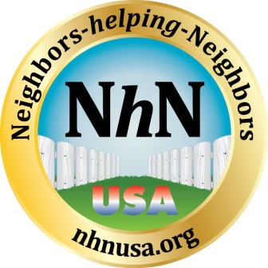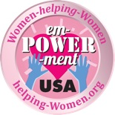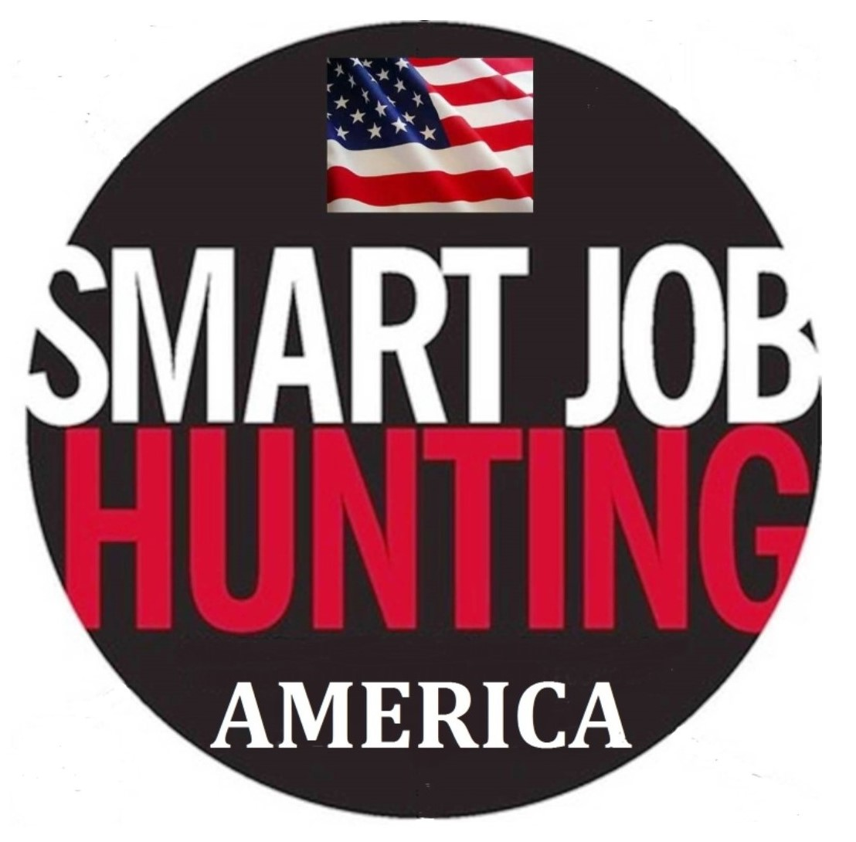

Neighbors-helping-Neighbors USA (NhNUSA) www.nhnusa.org is a participant cost-free, grassroots, nationally and internationally recognized and respected, Peer-led volunteer weekly job search support and networking group targeted to adults who are actively looking for work and interested in reinvigorating their job search. Membership is open to anyone in career transition, including unemployed or underemployed individuals, recent college graduates, and veterans re-entering the job market in the fields of business, non-profit, and education, as well as persons re-entering the job market, struggling small business owners and anyone looking for part-time or volunteer work.

Founded by John R. Fugazzie : www.johnrfugazzie.com and started in River Edge, New Jersey on January, 27, 2011, NhNUSA has fostered a “pay it forward” give back and an accountability weekly meeting model. The organization operated from May 24, 2012-December 24, 2017 as a 501 (c)(3) New Jersey nonprofit. The organization now continues its amazing growth helping people and the continued expansion under the leadership of its founder John R. Fugazzie.​

NhN Mission
NhN is a network of volunteer peer support groups that follow a community-based approach to help under-employed and unemployed residents get back to work. NhN embraces a ‘pay it forward’ ethos, asking all associates to contribute to other members by sharing job search techniques, related professional career development resources, personal referrals and generally providing a forum where members feeling empowered, energized and focused on the job search.
Goals
- Provide compassionate, nonjudgmental support to members through networking, coaching, leadership experience, and camaraderie.
- Partner with community business leaders to match members with job openings and volunteer and or paid consulting opportunities.
- Expand network reach throughout local communities where there is a need. Grant partner with Ready to Work NJ as the outreach organization to the Long Term Unemployed in NJ. Opening meeting groups in NJ Community Colleges. An international meeting in Madrid Spain. Expanding into other states through alliances. Award winning web site and an extensive online network using LinkedIn, Facebook and other social media vehicles.
Core Behaviors
- Be positive in approach and encourage others to remain positive when facing the inherent challenges of the job search.
- Be compassionate and firm, as needed, to maintain productive meeting atmosphere and consistent results orientation.
- Be active in respective home towns by developing the group and its role in each community.
- Take the extra step to help members by sharing personal network and job leads.
- Report your success story to help others stay motivated as they helped you to do.
Visit our Web site for more information - www.nhnusa.org Join our LinkedIn Group
http://www.linkedin.com/groups/NeighborshelpingNeighbors-USA-3892534

