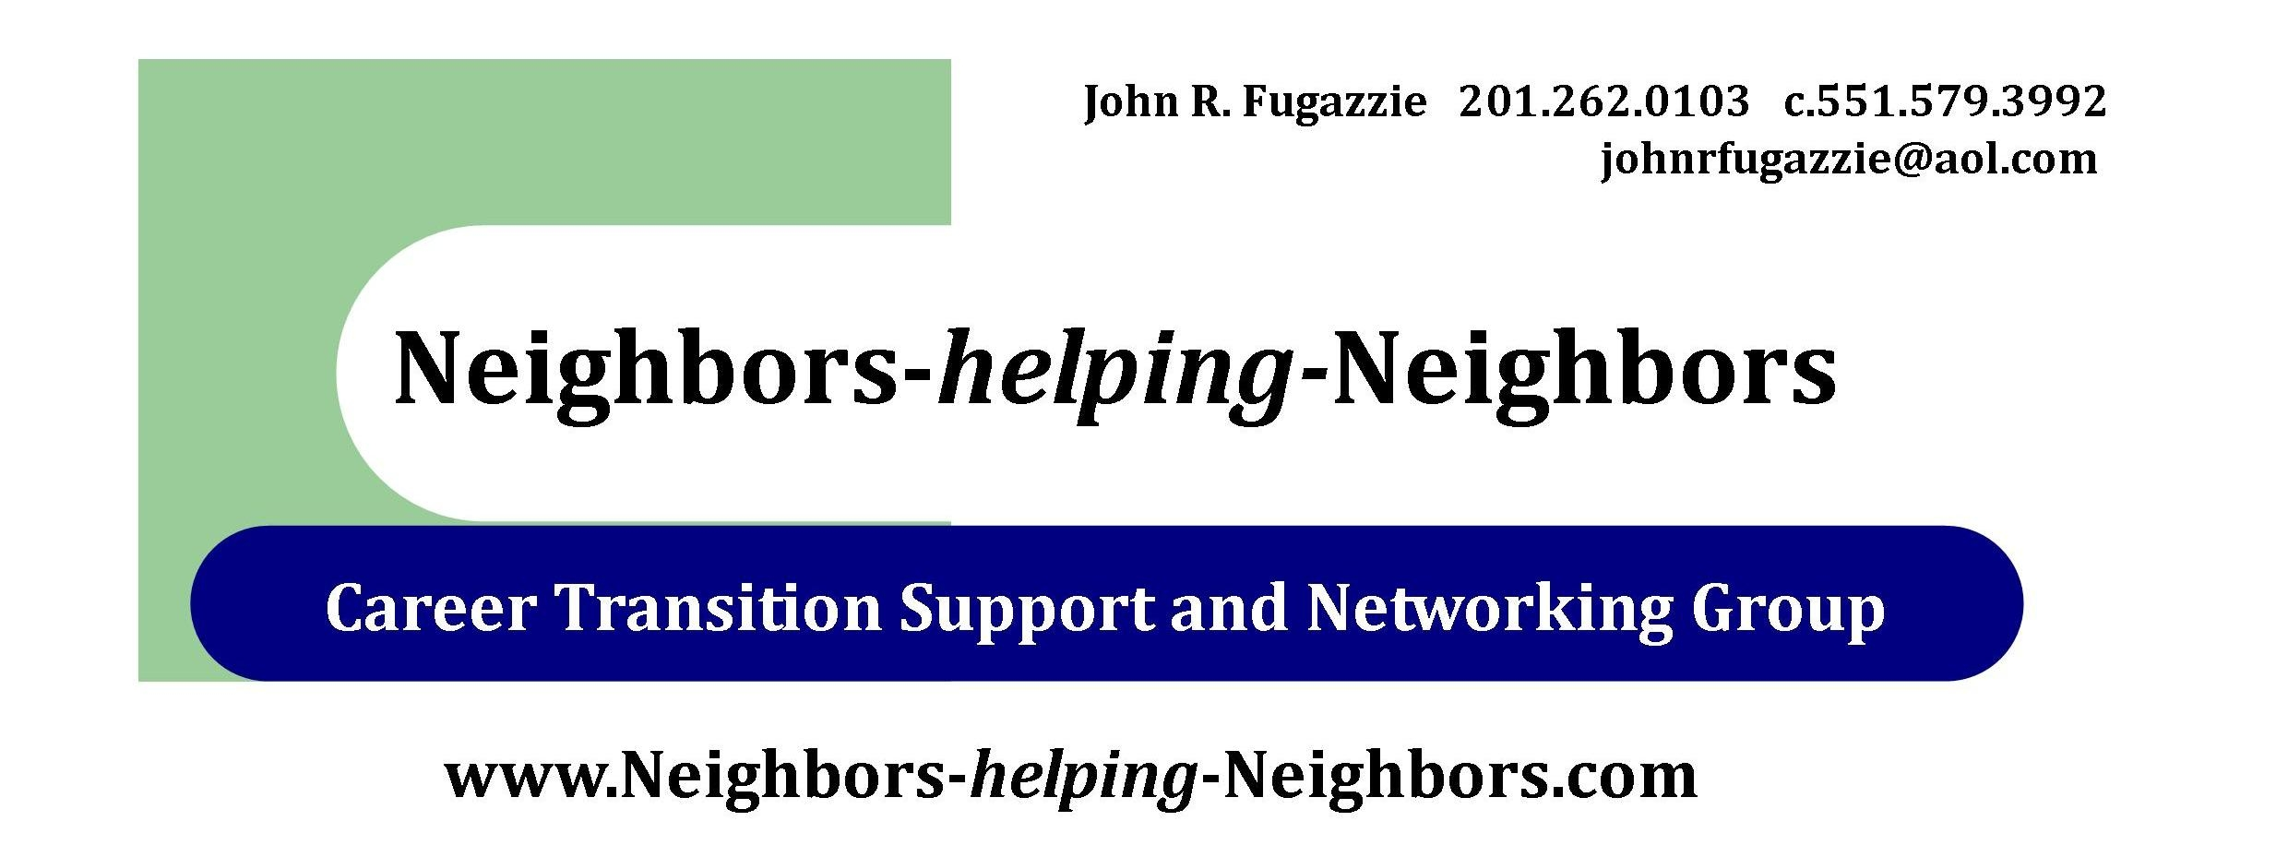

Speaking Engagements: Guest Speaker Procedure

NhN recognizes the value of professionals with expertise in areas related to career transition, and is grateful to those willing to volunteer their time and knowledge for the benefit of the group. However, the mission of NhN is to maximize the energy and resources of the group itself, and its priority is the weekly support and discussion that members offer each other.

To that end, the group will limit speaking engagements per location to once every four to six weeks, and the following requirements for accepting and arranging a guest speaker appearance must be followed:
- The volunteer speaker must submit a proposal/agenda and brief resume to the group leader, John Fugazzie (johnrfugazzie@aol.com).
- They must work with Mr. Fugazzie and the local group leader to schedule the speaking engagement.
- Speakers must limit their presentation to 45 minutes.
- Speakers cannot solicit work for themselves in any way (even the libraries prohibit conducting business on the premises) other than providing a business card or website, but only if and when asked.
- Endorsement by a regularly participating member is a plus.
- None of the presentation or materials left with our members can violate the no solicitation guidelines.

When approved the outside speakers must do the following:

1. Provide to the host library Information at least one week ahead regarding any equipment needs the speaker may have.

2. If the speaker has his/her own equipment, plan to stop by the library or
arrive early to make sure it is compatible with the library's system. While things
usually can be worked out, glitches do happen and it is best to have the time to resolve them before the audience arrives.

3. Information one week ahead about any needs for room set up, e.g. microphone,
lectern, tables? auditorium style seating, etc,

4. A minimum of one week ahead -- anything that needs to be photocopied must be
e-mailed directly to the library.

5. Anything else the speaker may require?
Neighbors-helping-Neighbors established Jan 27, 2011, the name, logo and materials are property of John Fugazzie founder and no duplication or use of these materials can be done with out express permission. Copyright © 2011 Neighbors-helping-Neighbors

